EVOLUTION OF HORSE
Horse evolution is often represented as a straight-line evolutionary sequence.
It began during the Eocene epoch.
Place of Origin
- The place of origin of the horse is North America.
- From here, horses migrated to Europe and Asia.
- By the end of the Pleistocene epoch, horses became extinct in their place of origin (North America).
- The horses now living in North America are descendants of horses that migrated from other continents.
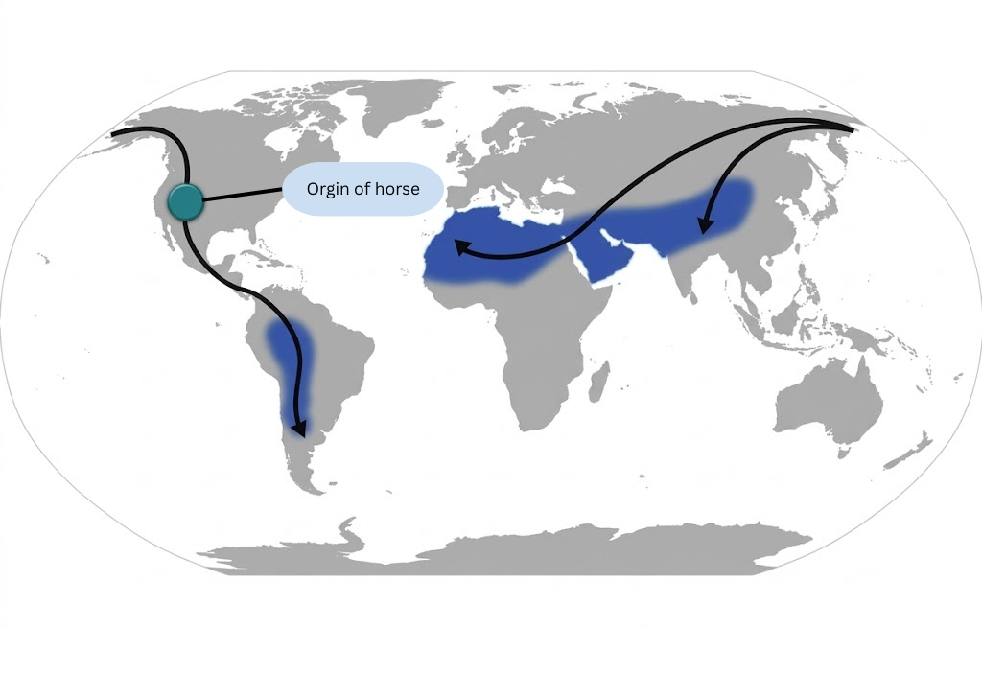
Evolutionary Trends
Fossils of horses from different geological periods show that their body parts underwent progressive changes in a particular direction.> Increase in size.
- Increase in body size.
- Increase in the length of limbs.
- Increase in the length of the neck.
- Increase in the length of the preorbital region (face).
- Increase in the length and size of the third digit (III digit).
- Increase in brain size and complexity.
- Molarization of premolars.
- Development of high crowns in premolars and molars.
Change from plantigrade gait to unguligrade gait.
- Disappearance of lateral digits.
- Enlargement of the hoof on the middle digit.
- Development of a springing mechanism in the limbs.
- Straightening and stiffening of the back.
- Transition from browsing habit to grazing habit.

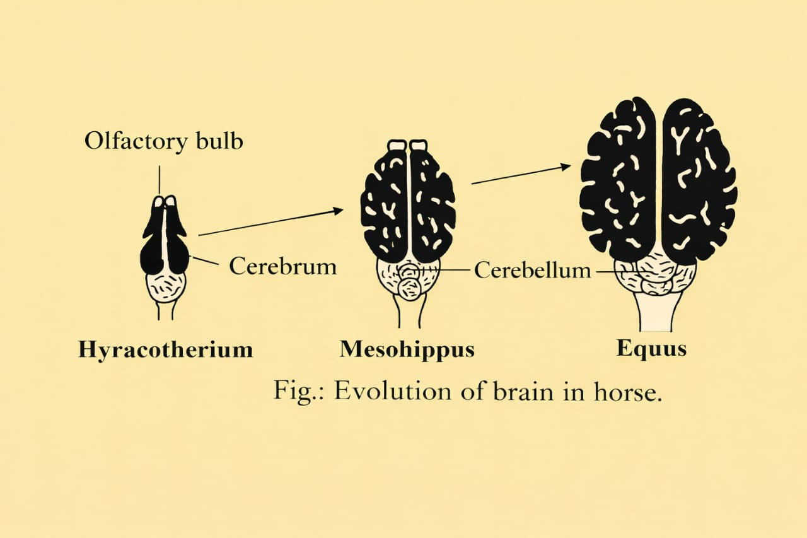
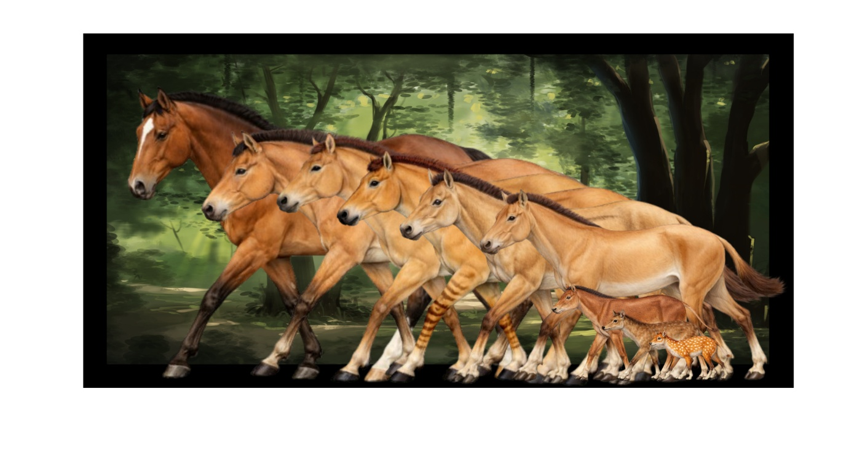

Evolutionary Sequence of Horses
Eohippus / Hyracotherium

Mesohippus

Merychippus

Pliohippus

Equus

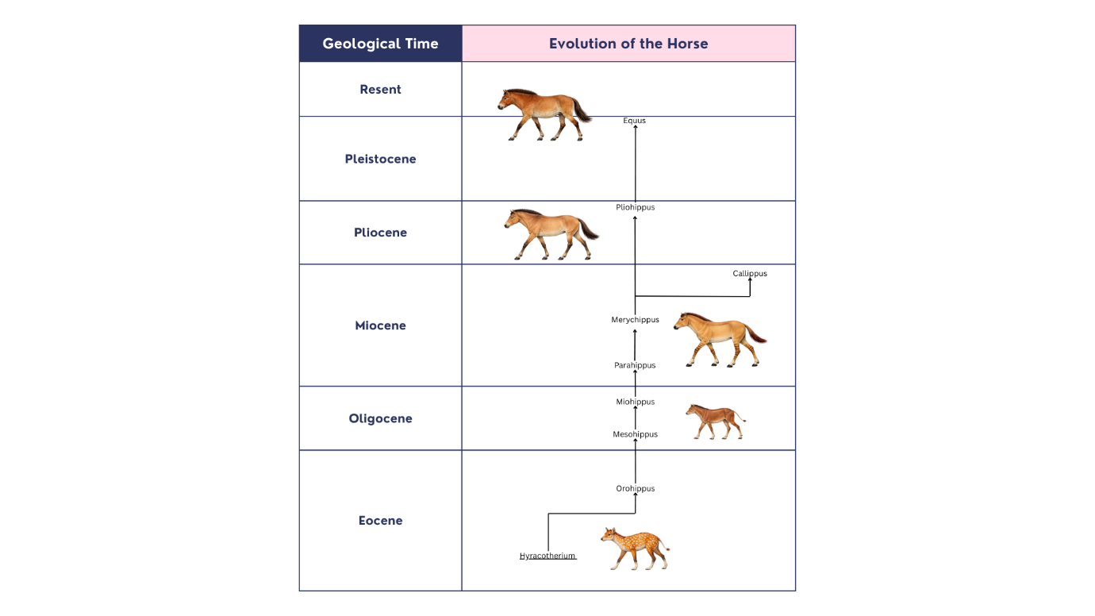

1) Eohippus / Hyracotherium
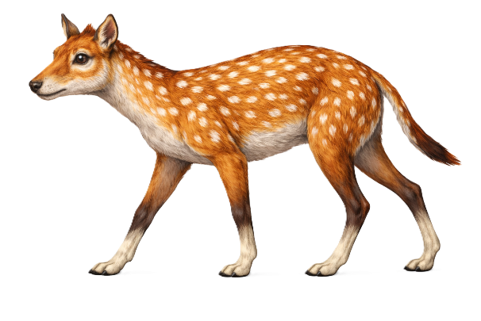
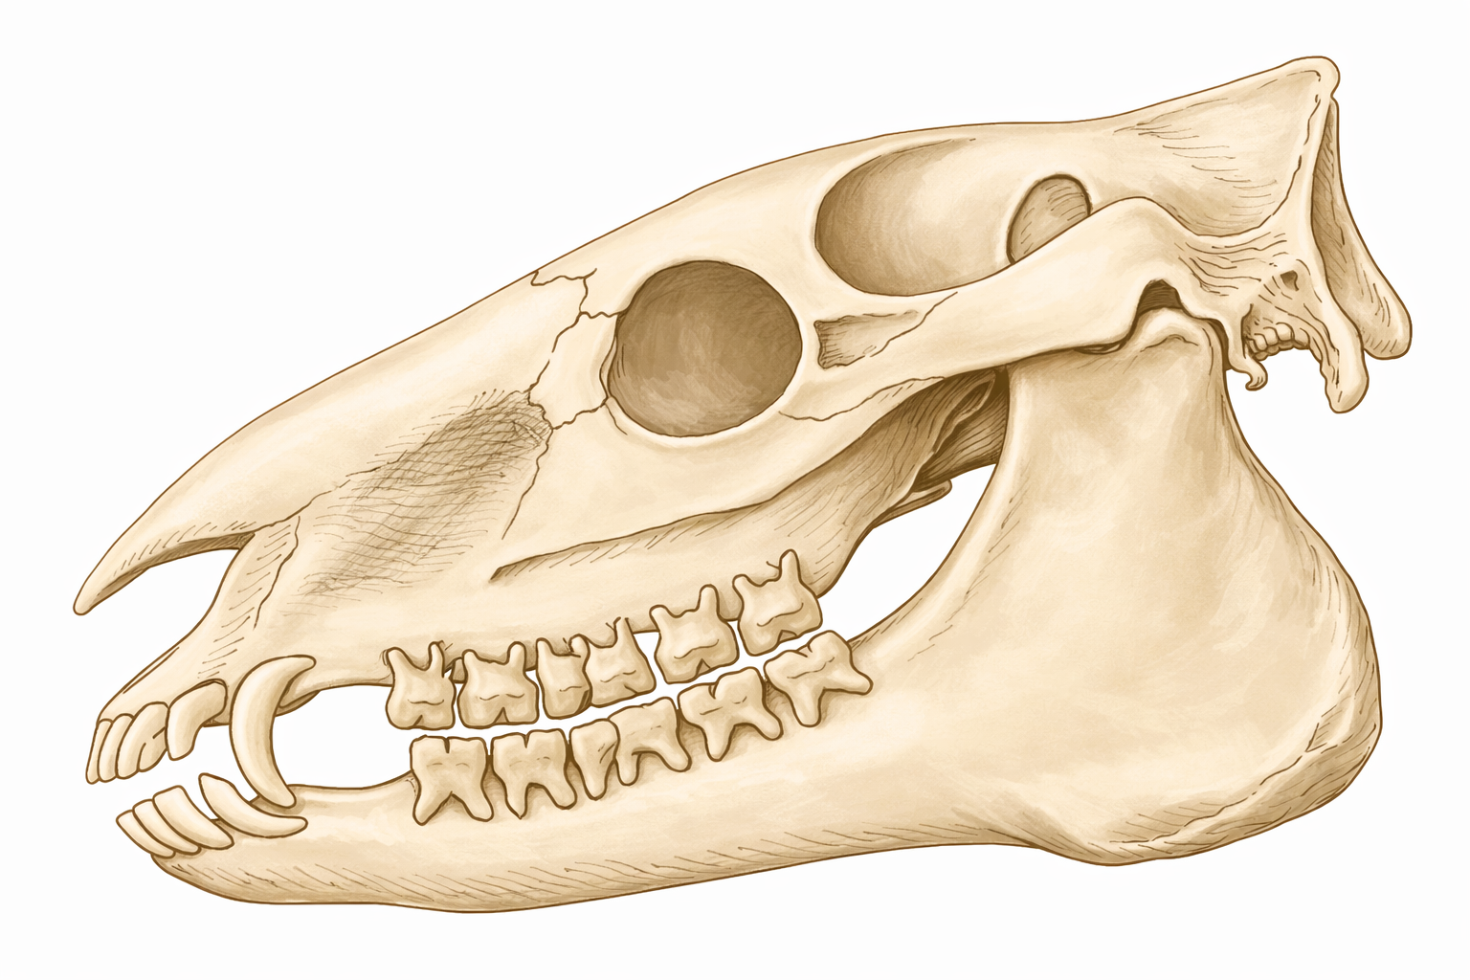
- Eohippus is the earliest known member of the horse lineage.
- It appeared during the Eocene epoch.
- Fossils were first discovered in North America.
- It was small, about the size of a fox or terrier dog, around 40 cm tall at the shoulder.
- It had a short head and neck.
- The forelimbs had four functional toes (2, 3, 4, 5) and a splint of the first toe.
- The hind limbs had three functional toes (2, 3, 4) and a splint of the fifth toe.
- Splints are reduced, non-functional toes.
- The teeth had poorly developed cement.
- The molars had smooth cusps without enamel ridges.
- The low-crowned molar teeth were adapted for browsing soft vegetation.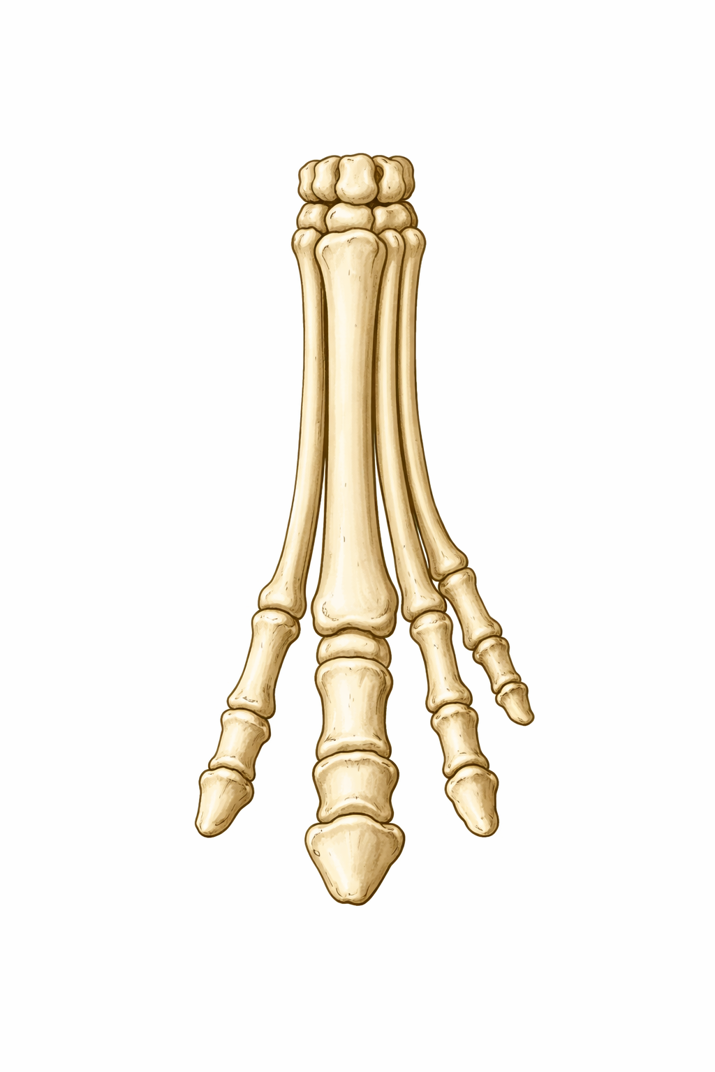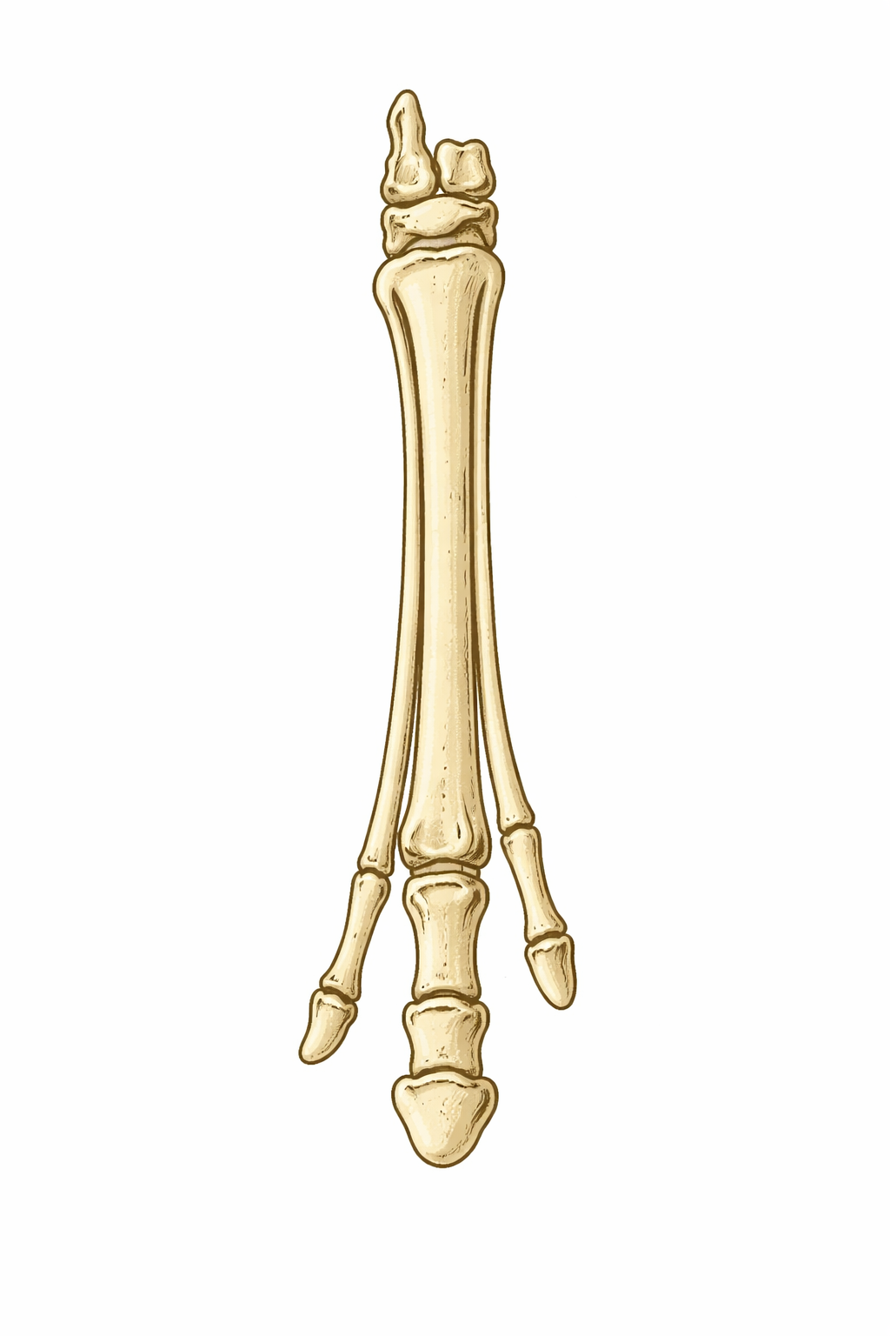

2) Mesohippus
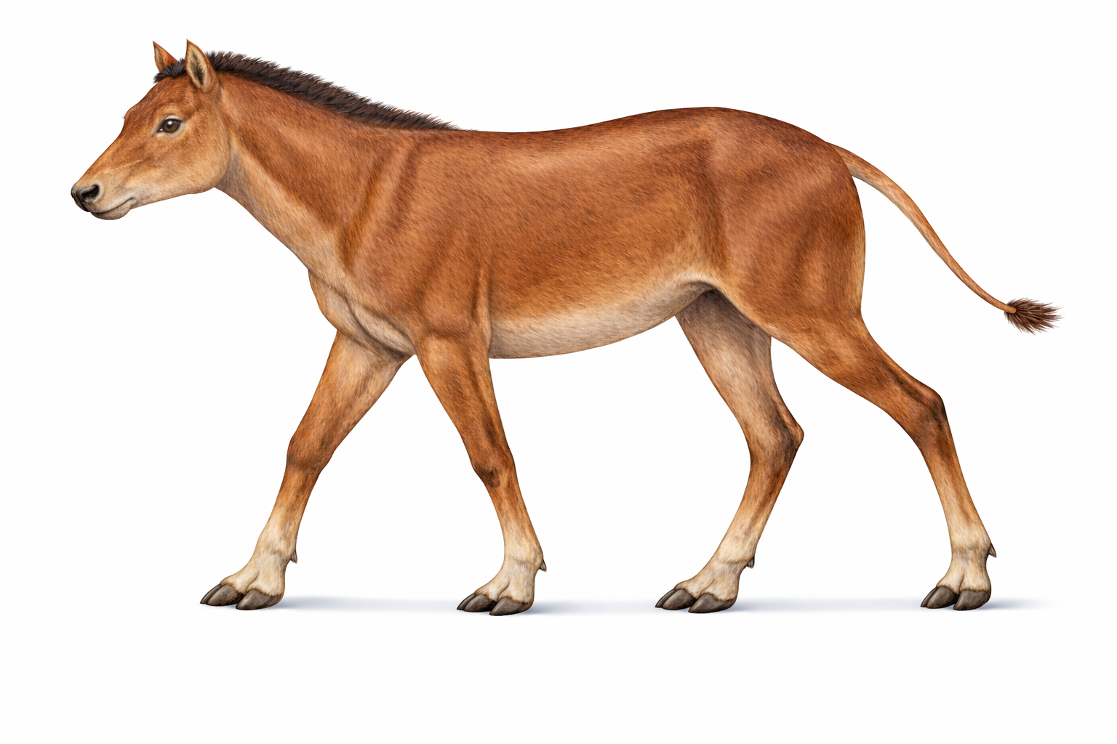
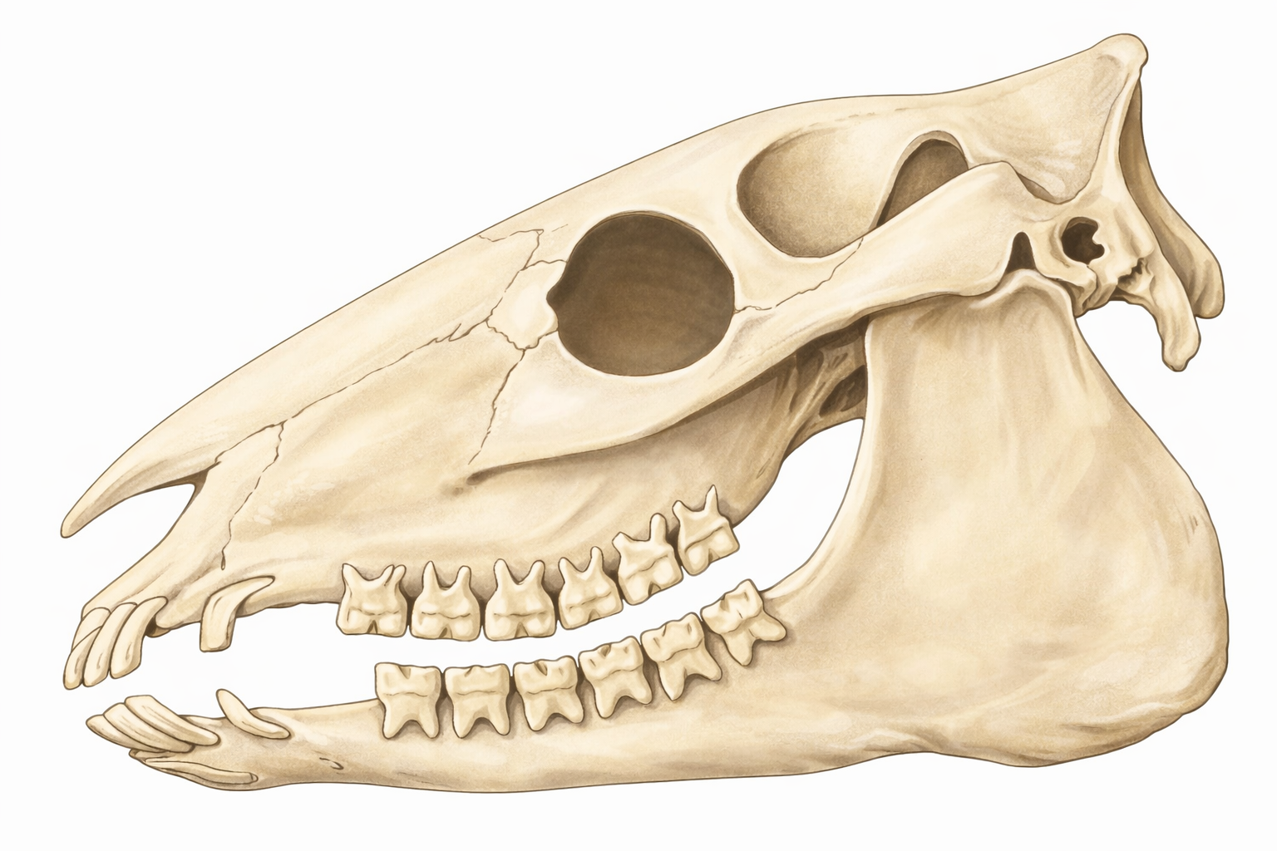
- Mesohippus represents an intermediate stage in horse evolution.
- It evolved from Hyracotherium (Eohippus).
- It appeared during the Oligocene epoch, about 3 crore years ago.
- It was about the size of a modern sheep.
- The height was about 60 cm at the shoulders
- The forefeet had three functional digits (2, 3, 4) and a splint of the fifth digit.
- The hind feet had three toes (2, 3, 4).
- The middle toe was longer and supported most of the body weight.
- The molar teeth showed the beginning of enamel ridges.
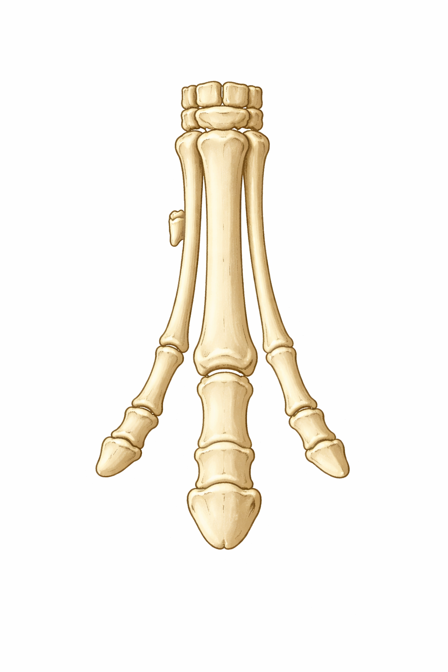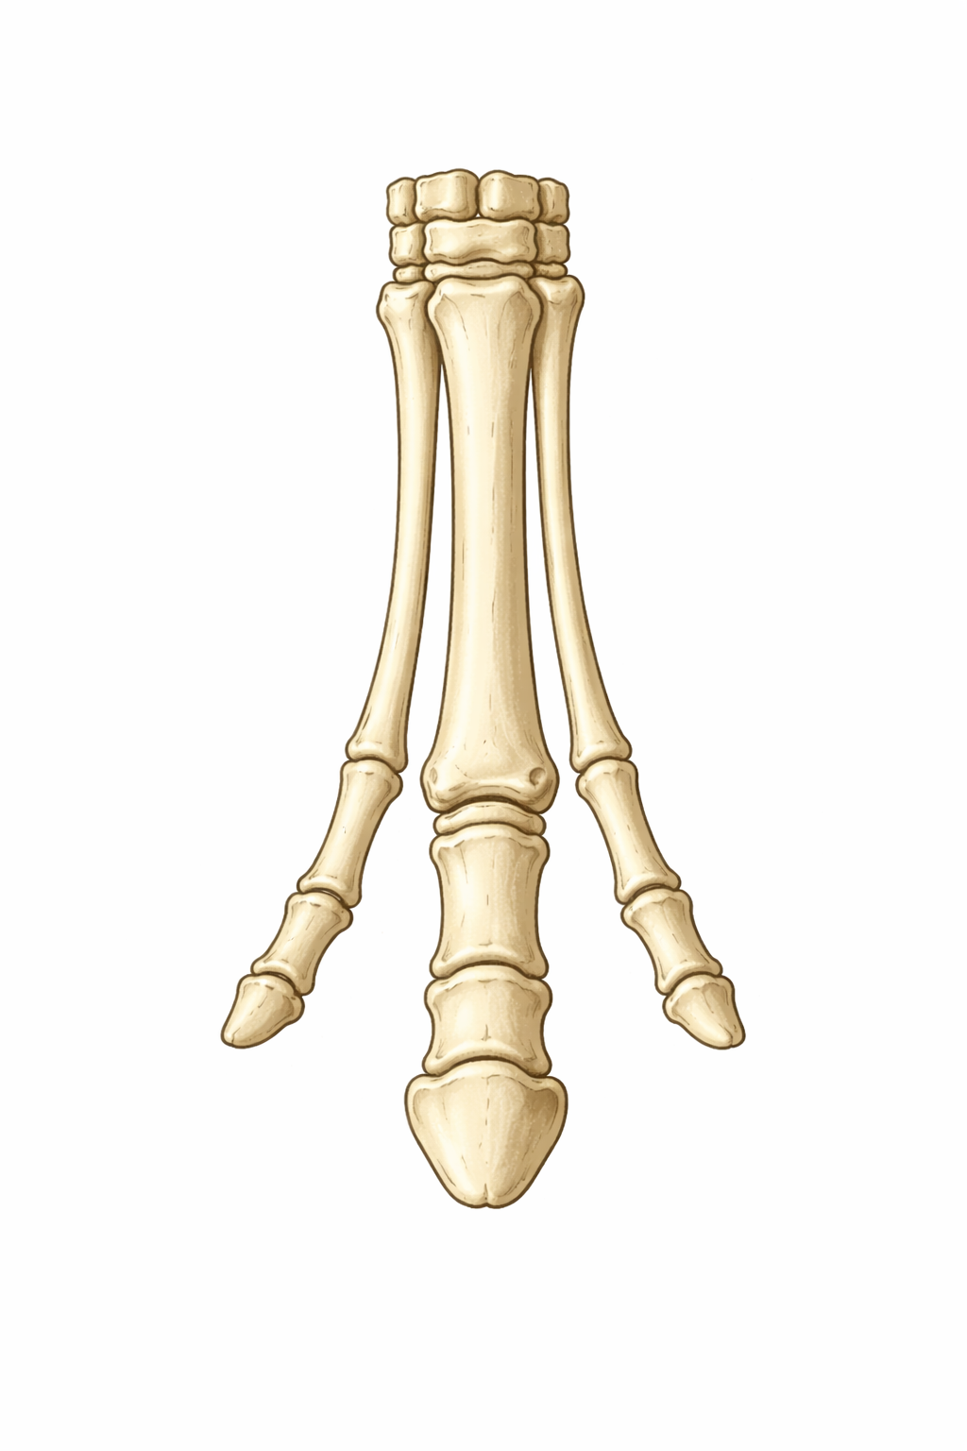
3) Merychippus
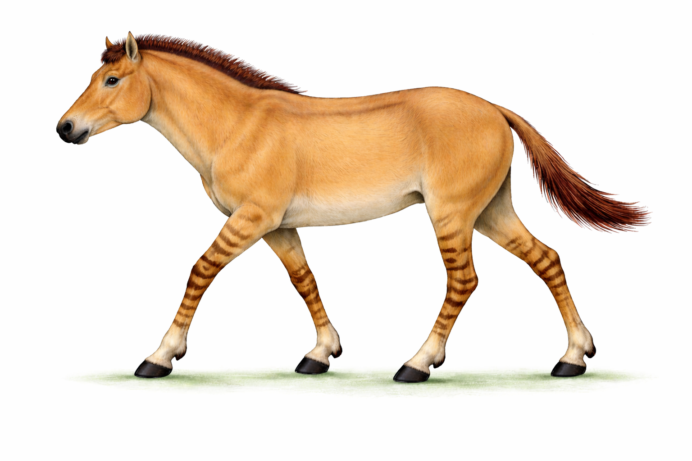
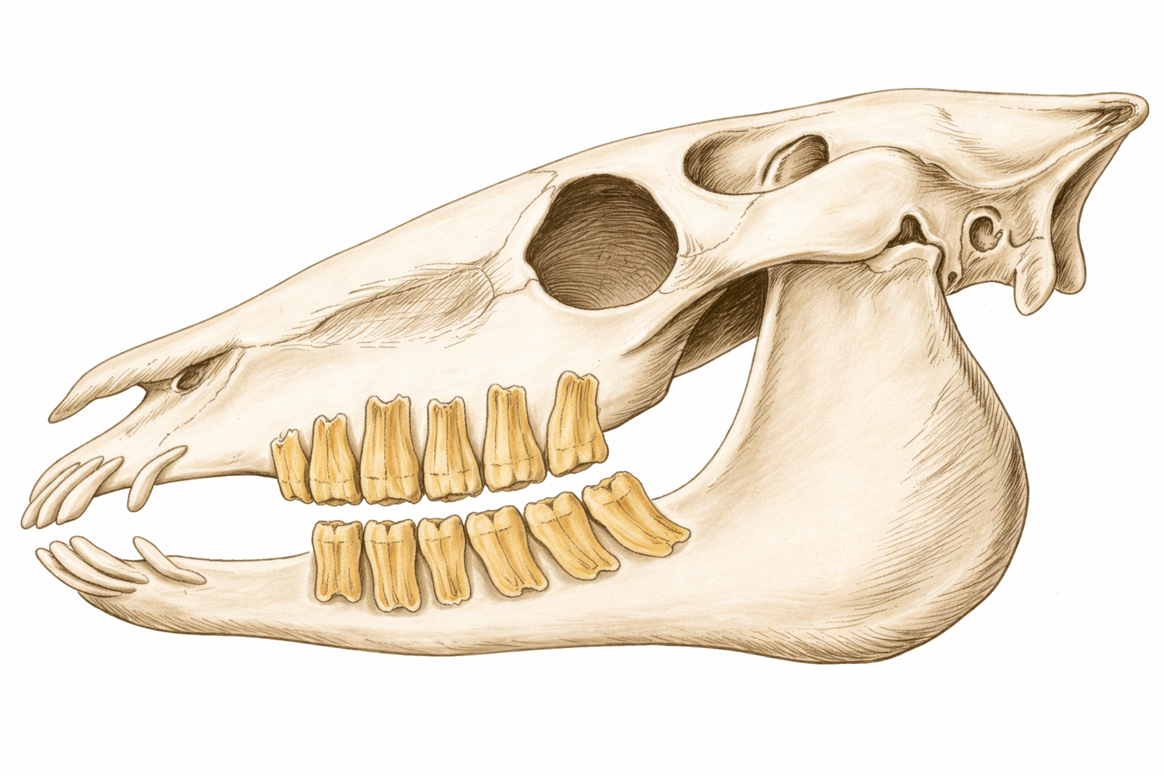
- Merychippus is known as the ruminating horse.
- It evolved from Mesohippus.
- It appeared during the Miocene epoch, about 2 crore years ago.
- It was about the size of a small pony.
- The height was about 100 cm at the shoulders.
- It had a longer neck.
- The forelimbs and hind limbs had three fingers/toes each.
- The middle finger and toe were longer and supported most of the body weight.
- The side toes were reduced and did not support body weight.
- The teeth were longer and covered with cement.
- The molar teeth had well-developed enamel ridges.
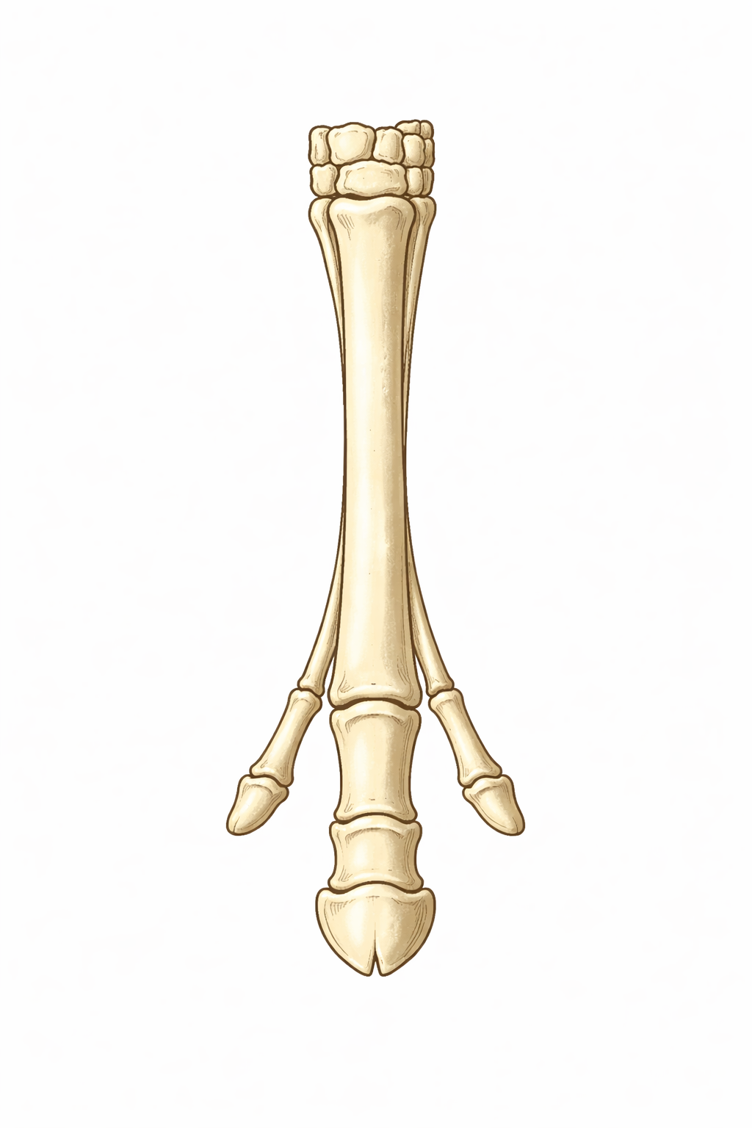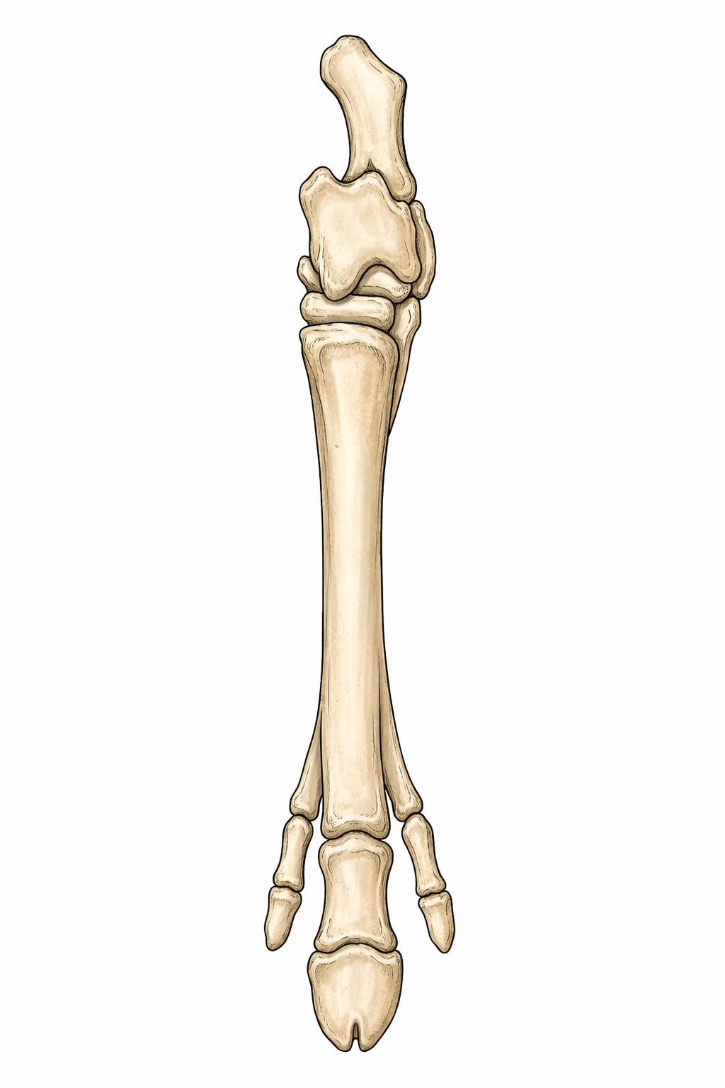
4) Pliohippus
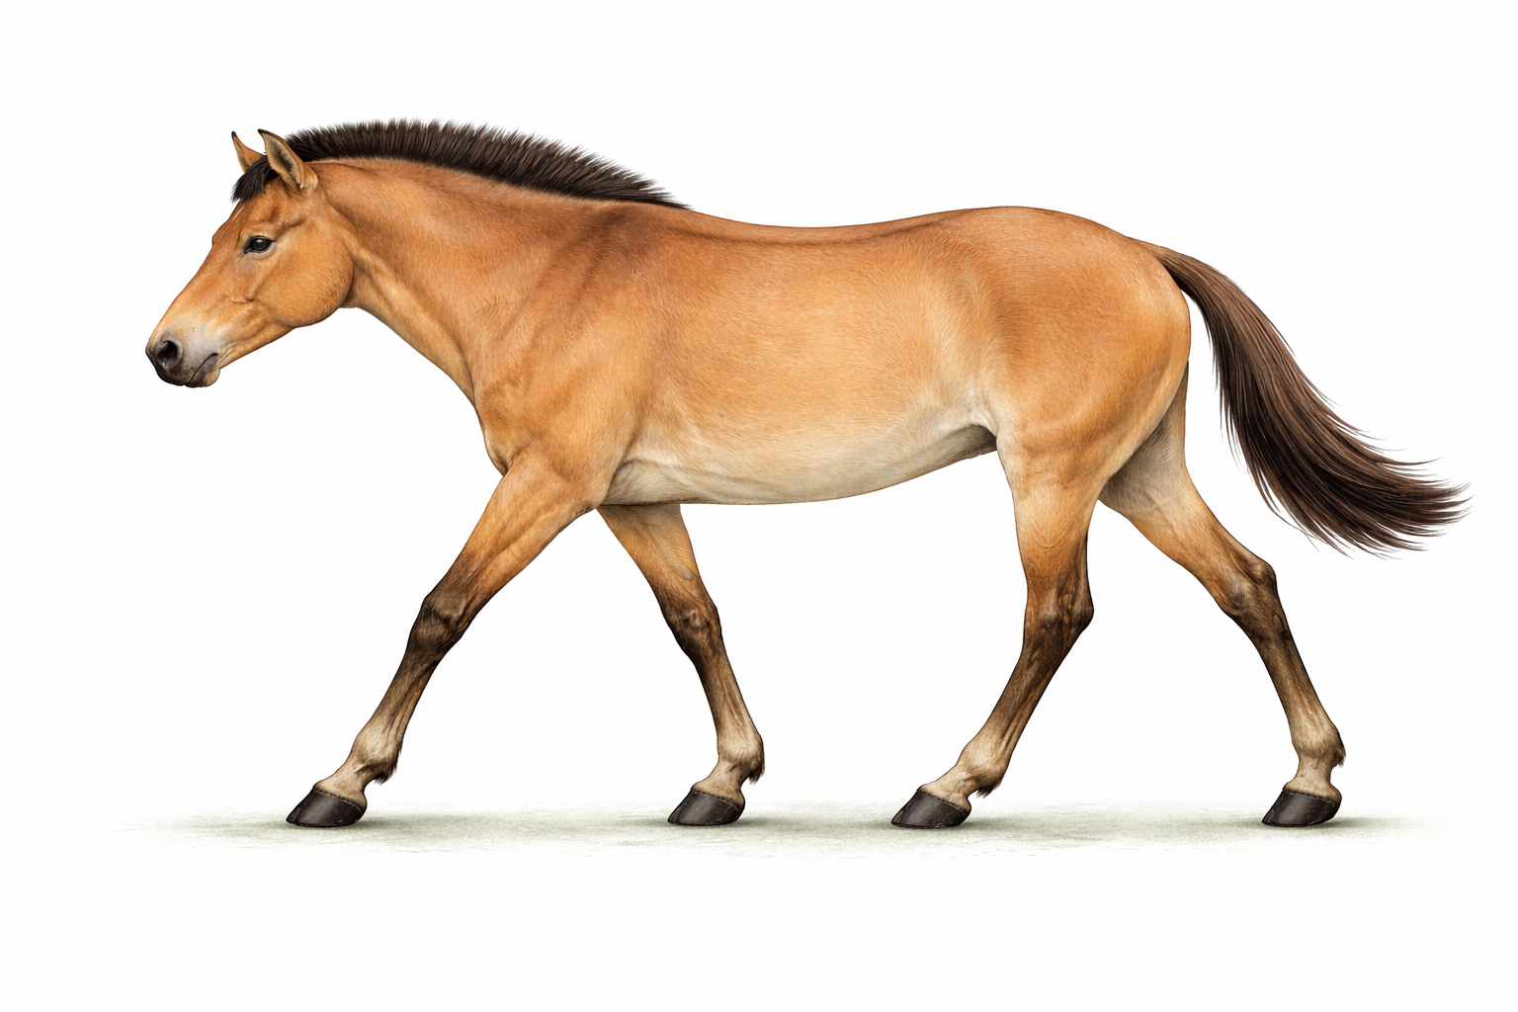
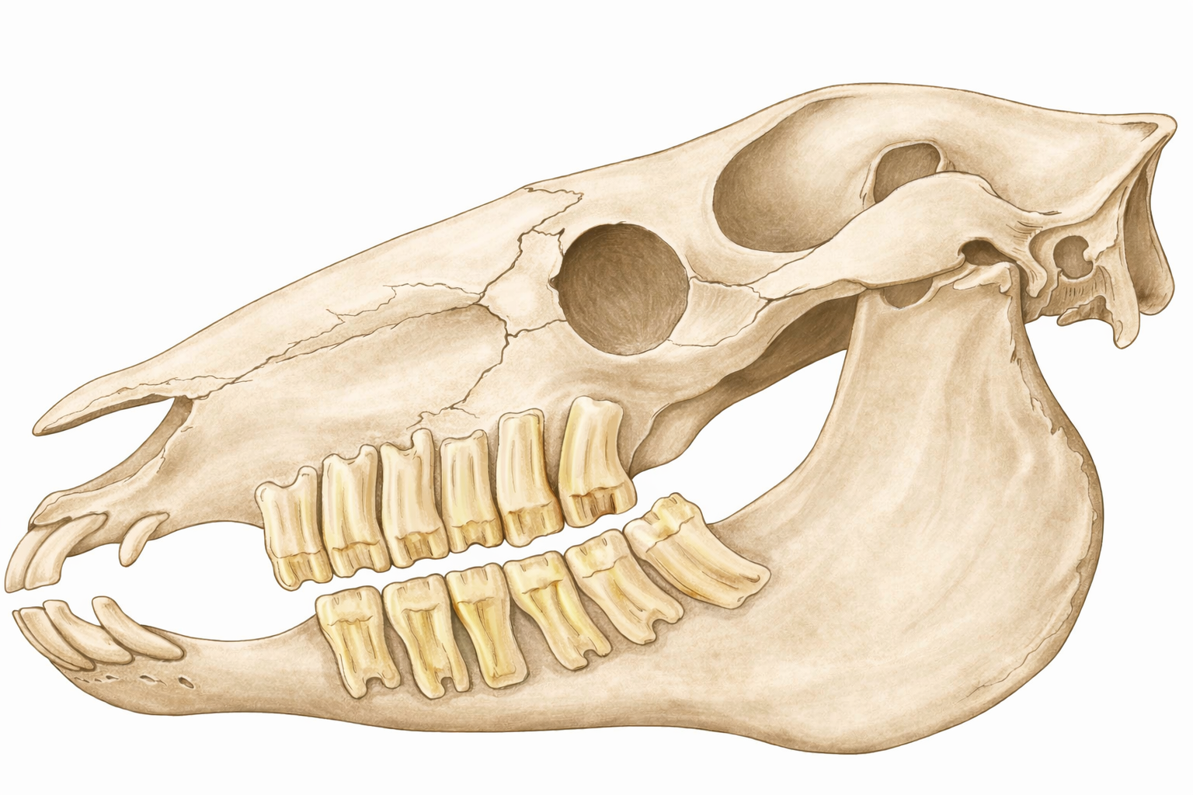
- Pliohippus was an advanced horse in evolution.
- It evolved from Merychippus-like ancestors.
- It lived during the late Miocene epoch (~12–6 million years ago).
- It was about the size of a modern pony.
- Height was about 120 cm at the shoulders.
- Each limb had one functional toe (digit III).
- Digits II and IV were reduced to splint bones beneath the skin.
- It is considered one of the earliest one-toed horses.
- Molars were high-crowned with cement and serrations, adapted for grazing grasses.
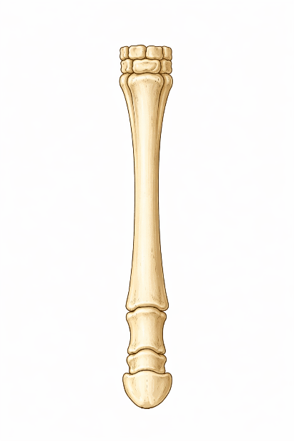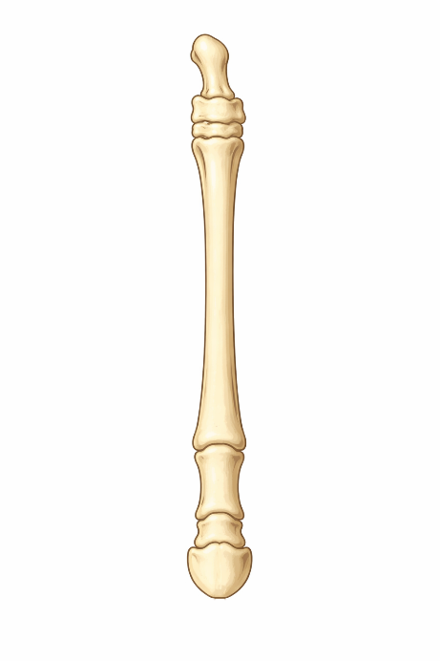

5) Equus cabllus (Modern Horse)
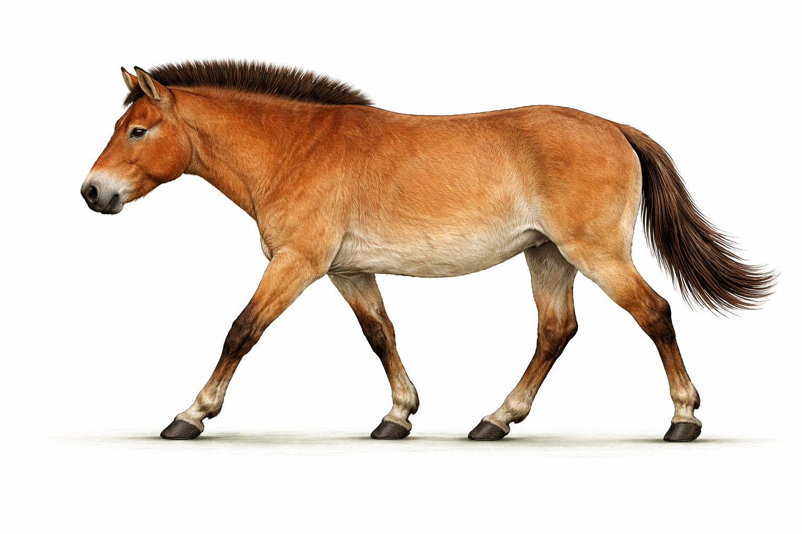
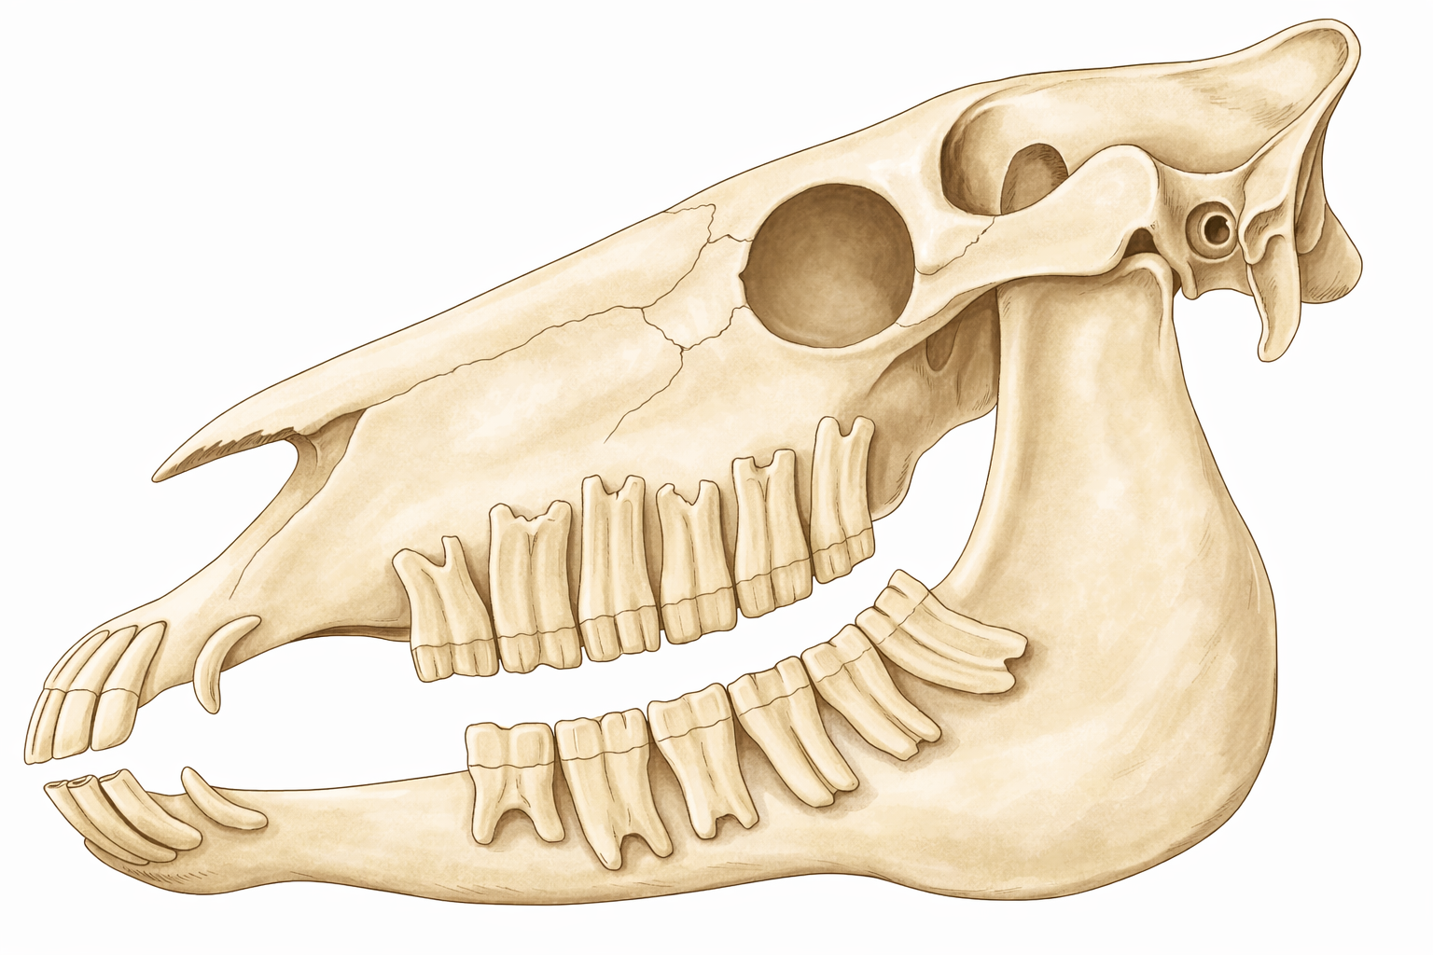
- Equus is the modern horse.
- It evolved from Pliohippus.
- It appeared during the late Pliocene epoch, about 4–4.5 million years ago.
- It first appeared in North America and later spread to other parts of the world except Australia.
- The height is about 150 cm at the shoulders.
- It has a long head and long neck.
- Each forelimb and hind limb has one functional digit (third digit) forming a single hoof.
- The other digits are reduced and present as two splint bones.
- The molar teeth have elongated crowns with enamel ridges.
- The teeth are highly suitable for grinding grass.
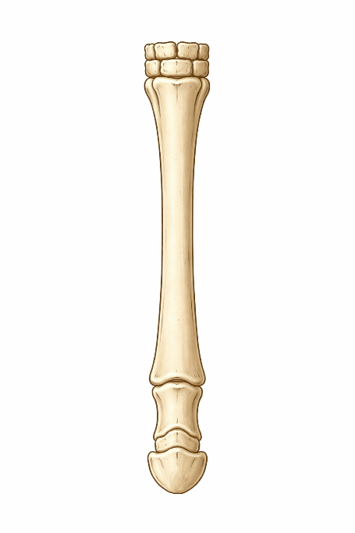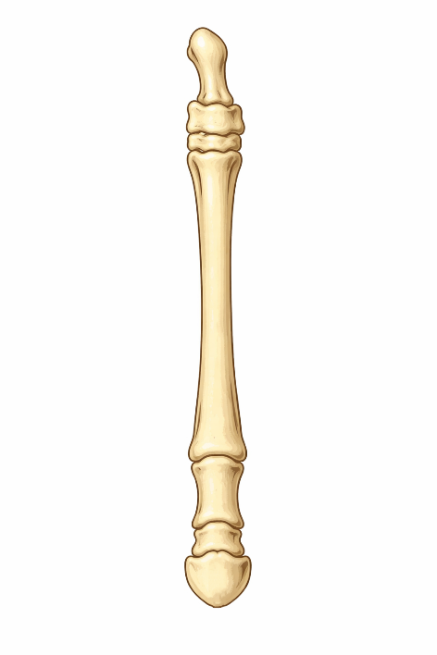

POINTS TO REMEMBER
- The evolution of the horse is based on fossil evidence.
- It shows gradual evolutionary changes rather than sudden changes.
- The structure of the teeth indicates a change in diet during evolution.
- Reduction of toes helped horses run faster.
- Horses originated in North America and later spread to other continents.

